
School of Computer Science Engineering & Information Science
A Report on
Mini-Project
Titled “Admission Management”

Course Title :- Web technologies
Course Code :- CSE2258
Date of Submission :- 21/11/2025

Submitted By :-
Name :- Diwakar Goswami, Manoj Kumar, Lithin, Priyanka, Aqram
Roll No :- 20241IST0100, 20241IST0098, 20241IST0097, 20241IST0099, 20241IST0096

Index
- Abstract
- Introduction
- Software and Hardware Requirements
- Modules/Functionalities
- Results with Screenshots
6. Conclusion

01.Abstract
An admission management web page serves as a digital facade and operational core for an educational institution's intake process. Its fundamental abstraction is the transformation of a complex, multi-stage, and human-centric procedure into a structured, automated, and data-driven digital workflow. It functions as a centralized system that mediates between the prospective applicant and the institution's administrative body.
02.Introduction
An admission management web page serves as the central digital gateway for an educational institution's enrollment lifecycle. In theory, it is a specialized web application designed to systematically transform the traditionally complex and paper-laden admission process into a streamlined, efficient, and transparent digital workflow. Its core function is to act as a bidirectional conduit for information, facilitating a structured interaction between the institution and its prospective applicants.
For the institution, the page is an administrative command center, enabling the configuration of admission cycles, program details, and eligibility criteria. It automates the collection, storage, and initial sorting of applicant data, replacing physical archives with a secure, centralized database. This digital foundation allows for the tracking of applicant progress through various stages, from submission to final selection, thereby enhancing operational control and data-driven decision-making.

03. Software and Hardware Requirements :
Software Requirements
- Operating System: Windows / Linux / macOS
- Web Server: XAMPP / WAMP / Apache server
- Database: MySQL (phpMyAdmin)
- Frontend: HTML, CSS, JavaScript
- Backend: PHP
- Browser: Chrome / Firefox / Edge
- Code Editor: VS Code / Sublime / Notepad++

Hardware Requirements
- A computer with minimum 4 GB RAM
- Processor: Dual-core or higher
- Storage: Minimum 2 GB free space for server, database, and project files
- Internet connection (optional – for external resource loading)

- Modules/Functionalities
1. Pre-Admission & Inquiry Management
This is the first touchpoint for prospective students and parents.
- Inquiry Form: A web form to capture lead information (name, contact, program of interest, source).
- Lead Dashboard: A centralized view of all new and existing inquiries.
- Lead Tracking & Scoring: Assign a score to leads based on their engagement (e.g., form submission, email open, event attendance) to prioritize follow-ups.
- Automated Communication:
  - Instant Acknowledgement: Auto-email/SMS confirmation upon inquiry submission.
  - Bulk Email/SMS: Send information about open houses, deadlines, and program details to a segment of leads.
- CRM (Customer Relationship Management) Integration: Log all interactions (calls, emails, meetings) with each lead to maintain a complete history.
2. Application Portal
The core module where applicants submit their information.
- Dynamic Online Application Form: A multi-step, user-friendly form that can be customized for different programs (e.g., Undergraduate, Graduate, PhD).
- Document Upload: Secure upload of required documents (transcripts, test scores, essays, letters of recommendation, passport photo).
- Application Fee Payment Gateway: Integrated payment processing (via Stripe, PayPal, etc.) with receipt generation.
- Save & Resume Later: Allows applicants to save their progress and complete the application later.
- Checklist & Status Tracker: Allows applicants to see a real-time checklist of received items and their application status (e.g., Submitted, Under Review, Accepted).
3. Admin & Backoffice Management
The powerful backend for the admission staff.
- Centralized Applicant Dashboard: A bird's-eye view of all applications with key metrics (total applications, pending reviews, accepted, etc.).
- Application Review & Processing:
  - Bulk Actions: Select multiple applications to update statuses or send communications.
  - Detailed Applicant Profile: View the complete application, downloaded documents, and activity history in one place.
- Document Verification: Tools to mark documents as "Verified," "Pending," or "Invalid."
- Internal Communication & Notes: Ability for staff to add private notes and comments on an application for collaboration.
- User & Role Management: Create different admin roles (e.g., Reviewer, Processor, Super Admin) with specific permissions.
4. Communication Center
A dedicated module to manage all outgoing communication.
- Email & SMS Templates: Pre-designed templates for common messages (acknowledgement, shortlist, offer letter, rejection).
- Personalized Bulk Messaging: Send emails/SMS to a filtered group (e.g., all applicants for the Engineering program) with personalization tags ([First_Name]).
- Automated Status Triggers: Automatically send notifications when an application's status changes (e.g., "Your application is now under review").
- Interview Scheduling: Allows staff to send interview invites with integrated calendar links (Google Calendar, Outlook) for applicants to self-schedule.
5. Evaluation & Selection
Tools to assess and score applicants.
- Custom Review Forms: Create digital scorecards with custom criteria (e.g., Academic Record, Essay Quality, Extracurriculars) for reviewers.
- Blind Review: Option to hide applicant's personal information to reduce unconscious bias.
- Committee Workflow: Assign applications to specific committee members and track their review progress.
- Decision Management: Streamlined process for making final decisions (Accept, Reject, Waitlist) and posting them.
6. Enrollment & Onboarding
Managing the transition from accepted applicant to enrolled student.
- Offer Letter Generation: Automatically generate and send personalized offer letters.
- Acceptance & Deposit: Allow students to accept the offer online and pay the enrollment deposit through the portal.
- Pre-Enrollment Forms: Digital collection of additional required forms (health records, housing applications, course registration preferences).
- Student Portal Activation: Automatically create credentials for the new student to access the main student information system.
7. Reporting & Analytics
Data-driven insights for strategic decision-making.
- Pre-built Reports:
  - Application Funnel Analysis (Inquiry -> Application -> Enrollment)
  - Demographic Reports (by geography, gender, etc.)
  - Program-wise Application Statistics
  - Source Effectiveness (which marketing channels bring the most qualified leads)
- Custom Report Builder: Drag-and-drop interface to create custom reports and charts.
- Data Export: Export any report or data set to Excel or PDF for further analysis.
8. System Administration & Configuration
The technical backbone of the application.
- Academic Cycle Management: Set up and manage admission cycles (e.g., "Fall 2024," "Spring 2025").
- Program & Fee Configuration: Add, edit, and manage academic programs and their associated application fees.
- Form Builder: Visually design and customize the application form without needing a developer.
- Integration Settings: Manage integrations with other systems (CRM, SIS, Payment Gateways, Email Service Providers).

- Result with Screenshots
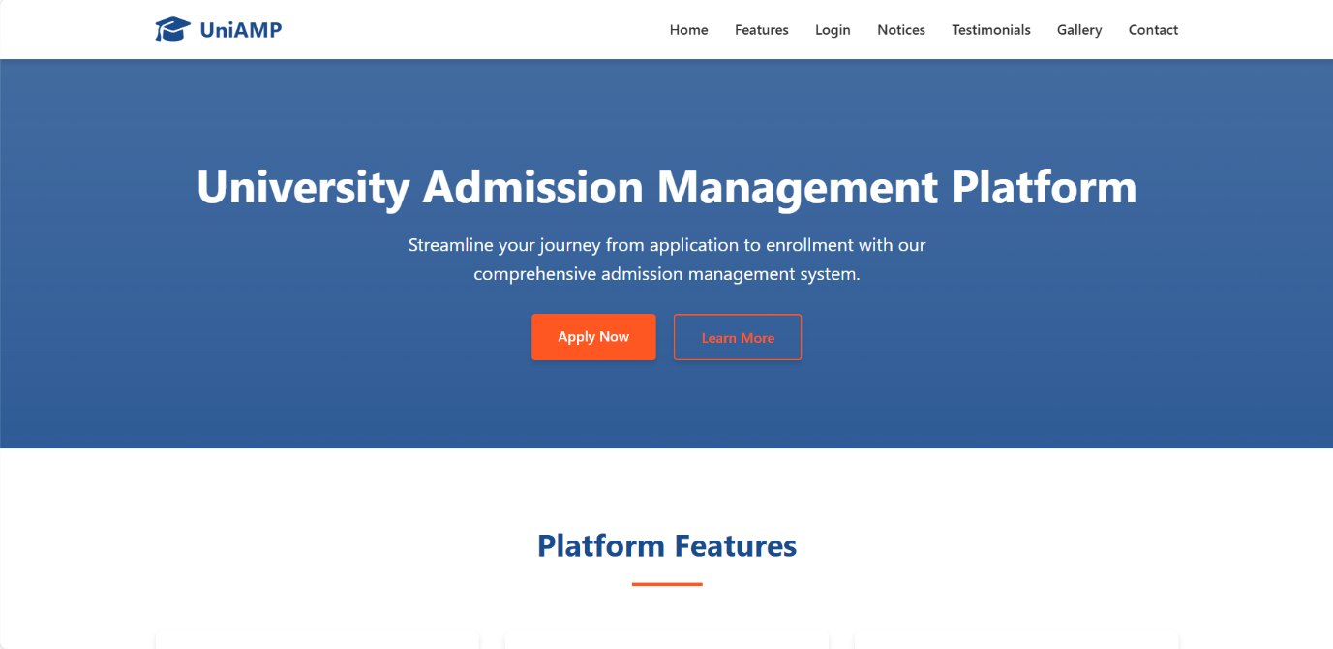

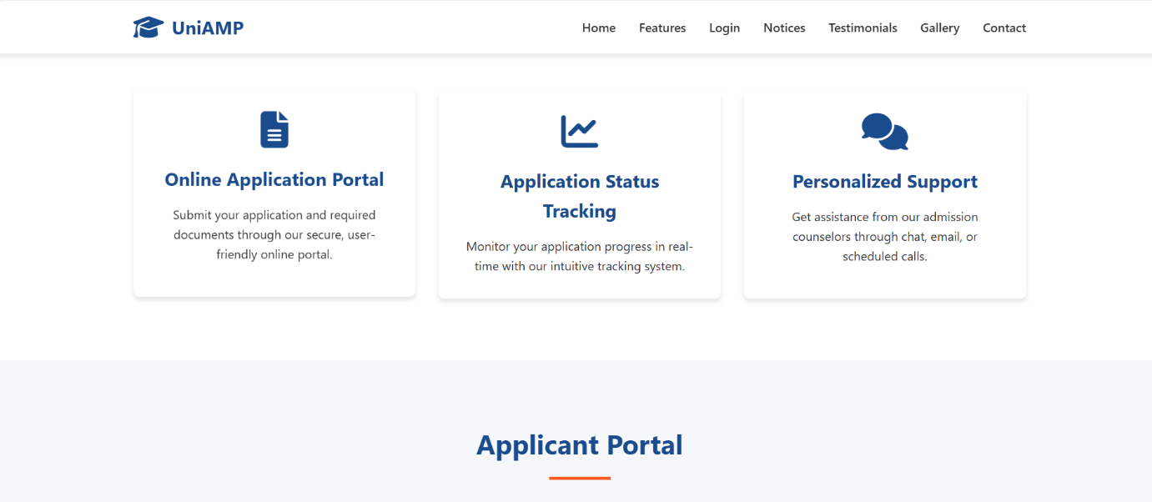
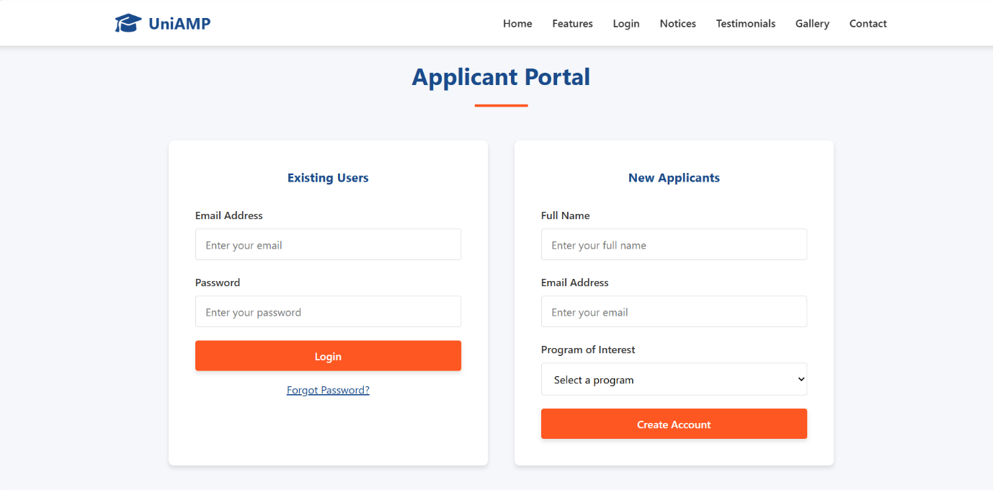
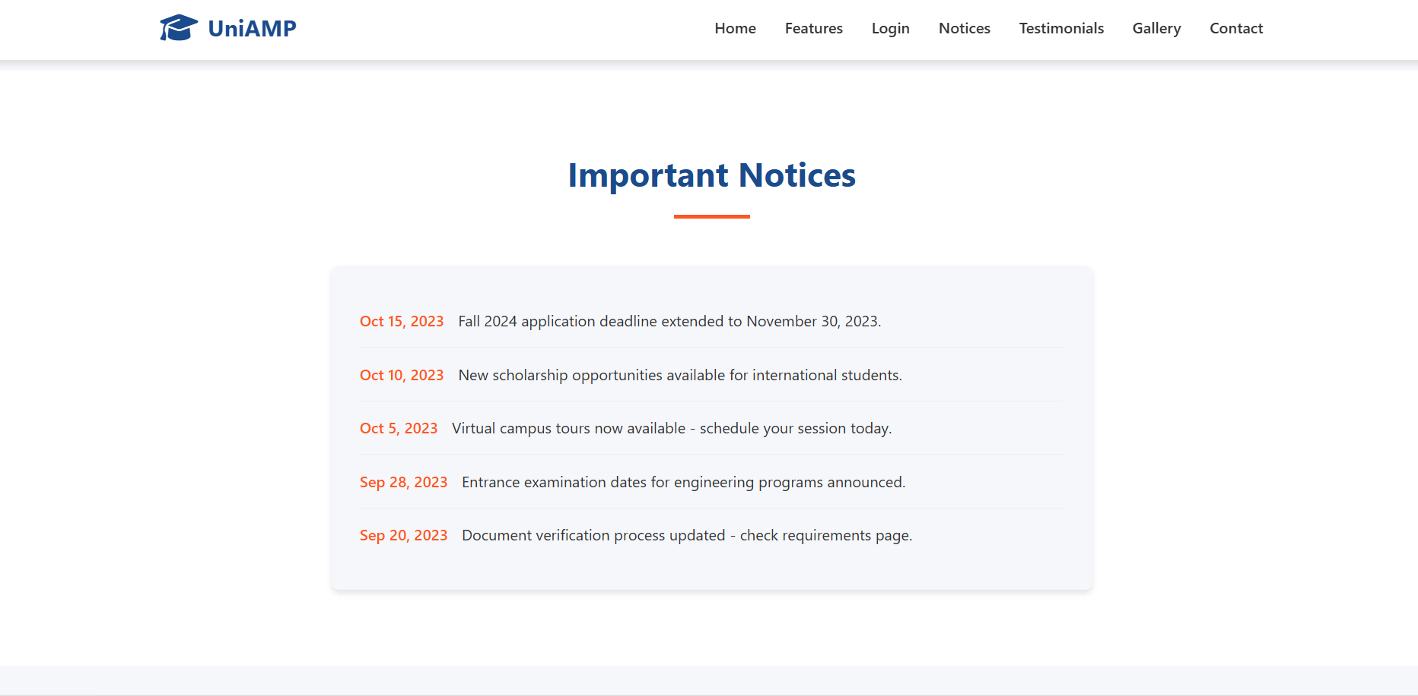

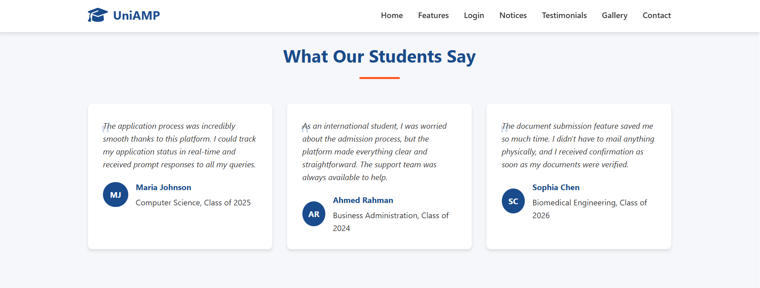


- Conclusion
In conclusion, the implementation of a modern Admission Management Platform is not merely a technological upgrade but a strategic imperative. By centralizing and automating the entire admissions lifecycle, the platform delivers transformative benefits: a significant boost in operational efficiency, a seamless and engaging experience for applicants, and powerful data-driven insights for enrollment strategists. Ultimately, this investment transcends administrative improvement; it is a critical step towards building a stronger, more competitive, and future-ready university, enabling the institution to attract and secure the best-fit talent for its academic community.

